[]

Version 1.0

# Overview

## Setting

* Year 3000
* Futuristic city
* Secret underground base

## Genre

* 2D, Platformer
* 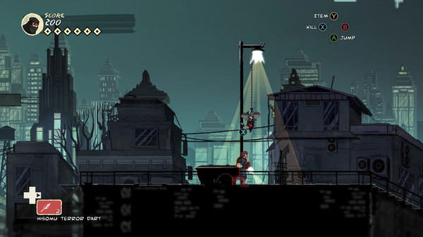Cartoon style, similar to Mark of the Ninja.

(Klei Entertainment, 2018)

## Core Gameplay Mechanics Overview

* Enemies
  + Robots that shoot on sight
    - Sentry turret
    - Humanoid Robots
    - Can be destroyed or shut down
* Humans
  + 5 States
    - Walk
    - Run
    - Idle
    - Shoot
    - Crouch
* Hazards
  + Lazer Grids
  + Electrical Platforms
* Upgradeable autonomous car which can assist the player
* Pneumatic tubes to secret areas
* Collectibles
  + Nitrous
  + Shield
  + EMP

### Story Delivery

The story will be delivered though short (10 seconds max) animated cutscenes and dialogue boxes. The player will be able to select responses to players talking to them – similar to RPGs.

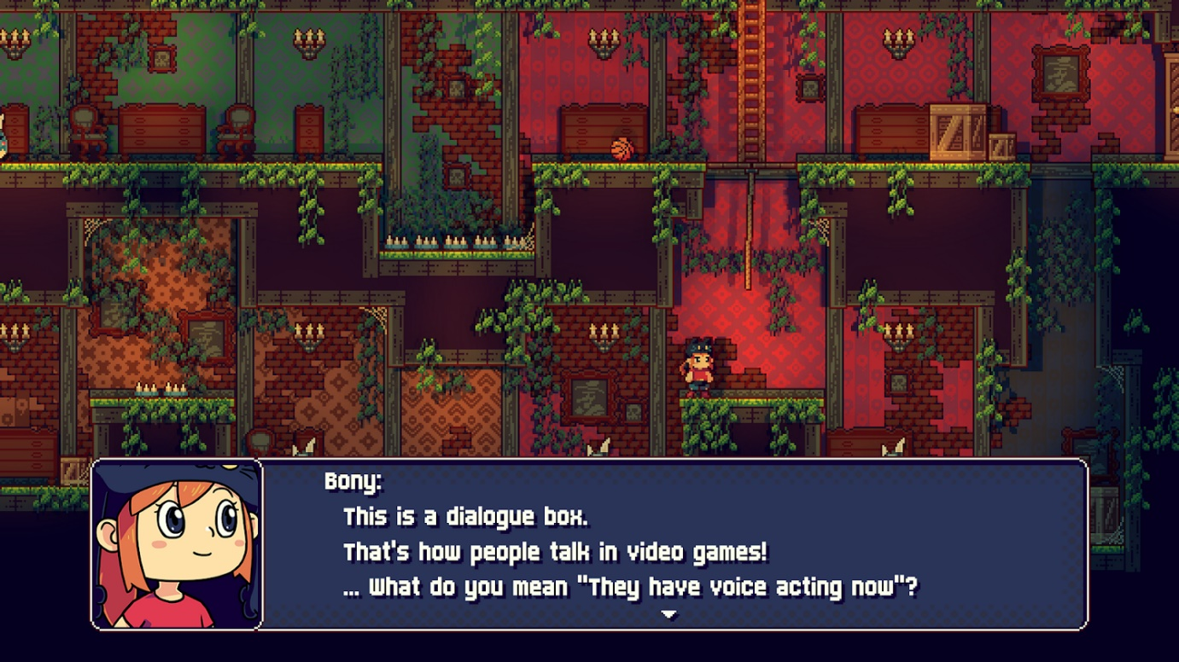

(Cursorama, 2018)

# Characters and Controls

## Player

* Protagonist

### Controls

* A and D – Move left and right (respectively)
* W or Spacebar– Regular jump
* S – Crouch
* Left Mouse – Shoot
* E – Activate EMP
* Q – Call Car

# Gameplay

## Levels

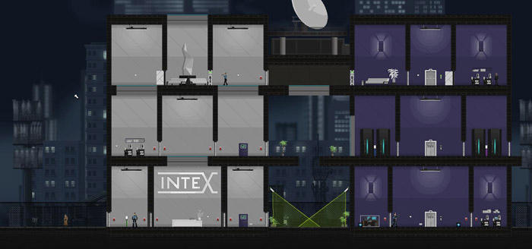The player must navigate through various 2D, side-on areas with different settings (rooftops, bases, etc), similarly to gunpoint, however these will be a mix of over-ground, underground, and secret facilities.

(Christopher, 2013)

## Scoring

For each level completed, the player will get a score.

The score will be based on the time the level is completed in, how many collectables are collected, and how many enemies are killed.

## Missions

### Saving

In the middle of a mission, there will be a checkpoint that the player can respawn to if they die.

### Success

When the player completes a mission, a screen will appear with the score and a continue button.

[Insert Pic]

### Failure

If the player dies, a fail state screen will be shown, allowing the character to restart the level, return to a checkpoint or quit.

[Insert pic]

## Collectables

During the course of a level, the player will be able to pick up collectables, which will affect how they interact with enemies and the world.

* Shield
  + The player gains a temporary shield. If the player gets hit while the shield is active, the shot will be blocked and the shield will deactivate.
* EMP
  + Any electrical devices on screen will be deactivated when the EMP is used. This includes electrical hazards and enemy robots.
* Nitrous
  + Once the player has collected 4 nitrous pickups, the player will be able to call in the car, which (depending on the configuration of the car) will assist the player for 10 seconds.

## Enemies

The player will face enemies that will get increasingly more difficult as the game progresses.

Enemy types will differ in appearance, from humans to robots and will act differently.  
Humanoid robots are slower than their real human counterpart. They will shoot the player when in sight.

Sentry robots cannot move, and will shoot the player when in range.

Humans are slower than robots, and are able to crouch behind cover. They have better aim. They will shoot at the player when they have knowledge of their location.

## End Game

At the end of the game; the player will infiltrate the now heavily-protected warehouse of the car manufacturer. It will feature all hazards and enemies and be the most difficult level in the game.

One the player has completed this level, a final cutscene will play. The player will enter the car and fly away.

# References

Ball, D., n.d. *Red dwarf XI mobile game mission fail screen.* [Online]   
Available at: https://www.pinterest.co.uk/pin/83246293091458743/?lp=true  
[Accessed 27 December 2018].

Ball, D., n.d. *Red dwarf XI mobile game mission success screen.* [Online]   
Available at: https://www.pinterest.co.uk/pin/83246293091458739/?lp=true  
[Accessed 27 December 2018].

Christopher, 2013. *Screen Cuisine.* [Online]   
Available at: http://www.screencuisine.net/screencuisine/video-games/seven-examples-of-gunpoints-great-design-choices-that-have-nothing-to-do-with-gameplay/  
[Accessed 27 December 2018].

Cursorama, 2018. *Medium.* [Online]   
Available at: https://medium.com/@cursorama/dialogues-and-conversations-in-adventure-games-8023ea7ef5e5  
[Accessed 27 December 2018].

Klei Entertainment, 2018. *Mark of The Ninja: Remastered Steam Store Page.* [Online]   
Available at: https://store.steampowered.com/app/860950/Mark_of_the_Ninja_Remastered/  
[Accessed 27 December 2018].